Weather Station Chip - User Guide
1. Purpose
Compact chip type Field Weather Station with two keys, 8 character LCD and 32.768 kHz internal clock. Three main functions: Mode to select parameter, Start/Adjust to clear/touch existing value or adjust time, and Mode + Start/Adjust (short press) for calibration and time setting.
2. What the Station Provides
- Total rainfall (mm)
- Instantaneous wind speed (m/s)
- Wind direction (compass text on the 8x1 display)
- Elapsed time
- Time of day (24 h)
- Optional: atmospheric pressure in mbar and air temperature in deg C
3. Device Overview (high level)
- Tipping-bucket rain gauge: pulse input (nRain, reed/switch)
- 3-cup anemometer: pulse input (nWind, reed/switch)
- Wind vane connected up via SPI to a 12-bit ADC (e.g. AD7466)
- 8-Character 1-Line HD44780 LCD (write-only in this design, RnW = GND)
- Mode and Start/Adjust (active low with pull-ups).
- Demo input: when high, the time base runs faster for bench demos (see section 9).
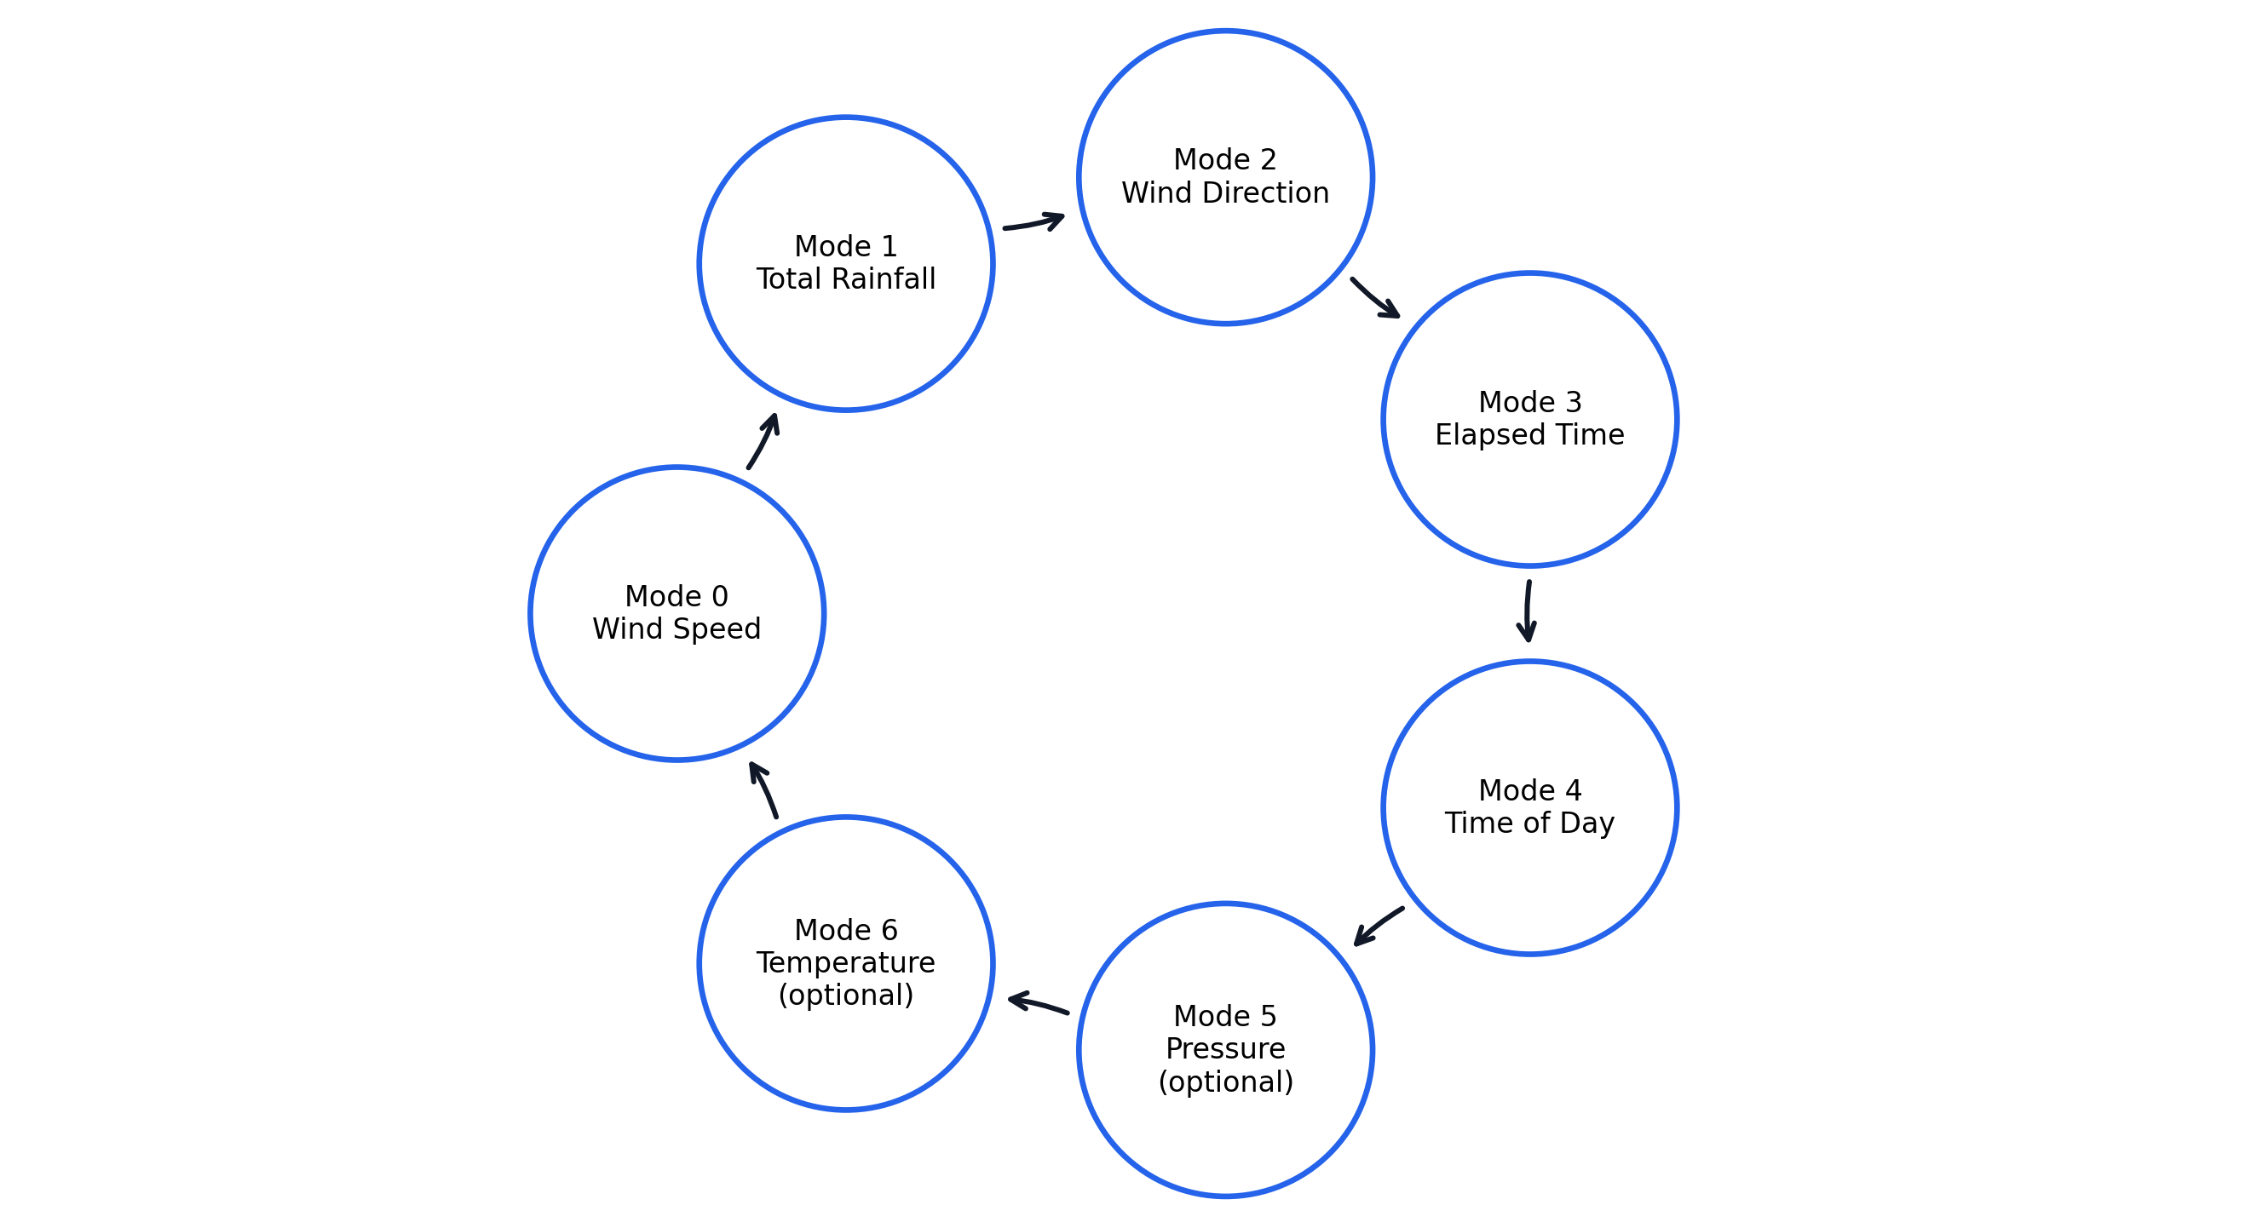
- Optional: barometric / temperature via SPI (e.g. MS5803) when that option is enabled.

Figure 1: Display mode state transition diagram for Weather Station user interface.
The diagrams below show the navigation for the MODE-button throughout all the states. The two optional modes Pressure and Temperature can be bypassed by disabling the optional sensors. Without optional sensors, the cursor returns directly from Time of Day to Wind Speed.

4. Installation and Good Use Practice
For optimum operation mount above open ground, away from nearby walls and obstacles.
Make sure the water level in the rain gauge and around the edge of the opening is clear of any obstruction.
Temperature measurements should be kept away from direct heat and sunlight. If your HYDRO Tracker comes with a sensor, ensure that it is not positioned close to direct sunlight or proximity to local heat sources.
Wait at least 500 ms after power on / reset before relying on readings from the display.
5. Range, Resolution, Accuracy (target / product; verify against calibration)
Mode | Range (typ. display) | Resolution | Notes
Total rainfall | 0.0-999.9 mm | 0.1 mm | Cumulative rainfall display.
Wind speed | 0.0-99.9 m/s | 0.1 m/s | Returns to 0.0 m/s after 2 s without pulses.
Wind direction | 16-point compass | ~22.5 degree step | Compass text shown on LCD.
Elapsed time | 00:00-99:59 | 1 min | Displayed as HH:MM in normal mode.
Time of day | 00:00:00-23:59:59 | 1 s | 24-hour format.
Pressure / Temperature | Sensor-dependent | Sensor-dependent | Shown only when optional sensor path is enabled.
6. How Each Function Works for the User
A) Total rainfall
Display shows accumulated rainfall in mm (ddd.d format). Press Start/Adjust once to clear the rainfall total.
B) Instantaneous wind speed
Display shows current wind speed in m/s. If no pulse is detected for 2 seconds, the display returns to 0.0 m/s.
C) Wind direction
Display shows compass text (e.g., N, NE, W). No user adjustment is required in normal viewing mode.
D) Elapsed time
Display shows elapsed time (HH:MM in normal mode). Press Start/Adjust once to clear elapsed time.
E) Time of day
Display shows 24-hour time (HH:MM:SS). Use Mode + Start/Adjust to enter time-setting flow (see 8.1).
F) / G) Temperature and pressure (optional)
These pages are shown only when optional sensors are enabled. Use Mode to view them like other display pages.
7. User Adjustment Functions
7.1 Setting time of day
Go to Time of day (Mode).
Mode + Start/Adjust in the dual-button window to enter time set sub-modes.
Sub-modes, in order:
Set hours - each press of the Start/Adjust button advances the set hours one digit, in BCD format, and rolls over from 23 to 00.
Mode -> Set minutes - Start/Adjust advances minutes.
Some Modes have a "Set seconds" option. In the "Set seconds - Start/Adjust" mode, the number of minutes up does NOT count. It resets the seconds to 00, and also resets the sixtieths display field accordingly.
Mode again (while on the seconds step) exits to normal Time of day view.
So: the third Mode press to go through the sequence (hours->minutes->seconds) to go back to the clock format, not to start adding seconds, and the Start/Adjust on the seconds step is to reset the seconds to 0.
7.2 Rain and wind calibration
Reference Total rainfall or Instantaneous wind speed on the display, and use Mode + Start/Adjust to enter the relevant calibration page.
Step through 4 decimal digits (4-digit BCD multiplier shown on the LCD), e.g. 1.035. Digit 3 (thousands) -> 2 -> 1 -> 0. Then a further Mode press takes you back to the same function you started from and the value is stored.
Start/Adjust in that screen increments the selected digit.
Behavior: The rainfall and wind path display the path of rainfall and wind over time using 4 digits (like the mode field) and a multiplier 1000 to represent the increase of 1.000x per digit as time progresses. However, the rules for editing these fields are different from each other (the rain field uses a stepped increment based on the weight of each digit; the wind field is incremented on a per digit 0-9 basis), yet the same structure of four decimal places (multiplied by 1000) and Mode advances digit/exit behavior is used.
7.3 Single Start vs Mode+Start (important)
A short Start/Adjust can reset elapsed time, and also (via the rain block) clear rain on a simple press. You should plan for this scenario, though; in practice, you'll probably want to clear one type of press without the other, and may want to use dual chips or separate the behavior in software in a future revision. This document describes current behavior.
A Mode + Start/Adjust within ~100 ms is considered a chord to enter time set / calibration. This timing difference is built into the FSM and written such that a chord does not issue the single Start elapsed clear typical of a single Start press, but physically releasing and then re-engaging either the Start or the Adjust switch to process a "chord" could still result in you losing your rain counts if not mindful of the key press interaction.
Operational warning (important): Start/Adjust shared across elapsed reset, rain clear and adjustment increments.
Avoid unintended clears by not pressing the Start/Adjust button before recognizing the Mode+Start chord.
Program the lock in the Programming Mode in the correct sequence: First press and hold the Mode button then quickly press the Start/Adjust button within the button press.
8. Demonstration mode (Demo high)
With Demo asserted:
Now there is a 2nd 1 Hz tick. Also, in Demo mode time-related actions will behave 60x faster than real time to make demonstration of products and features on the client side more effective.
The elapsed time on the LCD is displayed in MM:SS instead of HH:MM.
The time of day is represented in the format MM:SS:xx, where MM is the number of minutes, SS is the number of seconds, and xx represents the sixtieths of a second. The time of day display repeats every 24 "demo minutes", which is equivalent to 24 hours.
Note that for Demo mode, only the time bases and displays which use the divided clock have their speed increased, while rain, wind, and direction do not. In addition, both regular and Demo speed up the direction of the rain, wind, and everything else, and all of these are increased by the same ratio, while the speed of the time bases and displays that use the divided clock are increased by a different ratio.
9. Error and Limitations (summary)
Key limitations:
- Demo must be OFF for real-time interpretation.
- Long-term time accuracy depends on the external 32.768 kHz clock tolerance.
- Wind direction accuracy depends on ADC and analog tolerance.
- Reed-switch bounce and debounce timing (~25 ms) can affect rain/wind pulse counting.
Recommended acceptance criteria:
- Time-base drift (Demo OFF): as defined by external 32.768 kHz clock tolerance.
- Wind speed error: +/-0.67 m/s equivalent near 1 Hz baseline.
- Rainfall total error: +/-0.28 mm per tip equivalent.
10. Troubleshooting
Symptom | What to check
No button press | Wiring, active-low switch detection, and external pull-up on board.
Rain/Wind wrong | Reed alignment, cabling integrity, and Demo mode OFF during timing tests.
Unstable / blank direction | Vane, SPI lines, supply, and ADC reference path.
Incorrect time | 32.768 kHz source, reset state, and Demo mode status.
Time too fast | Demo input high (60x in Demo mode).
Unwanted clearing on Start | Start is shared across elapsed reset/rain clear/adjust increment; use proper chord timing.

